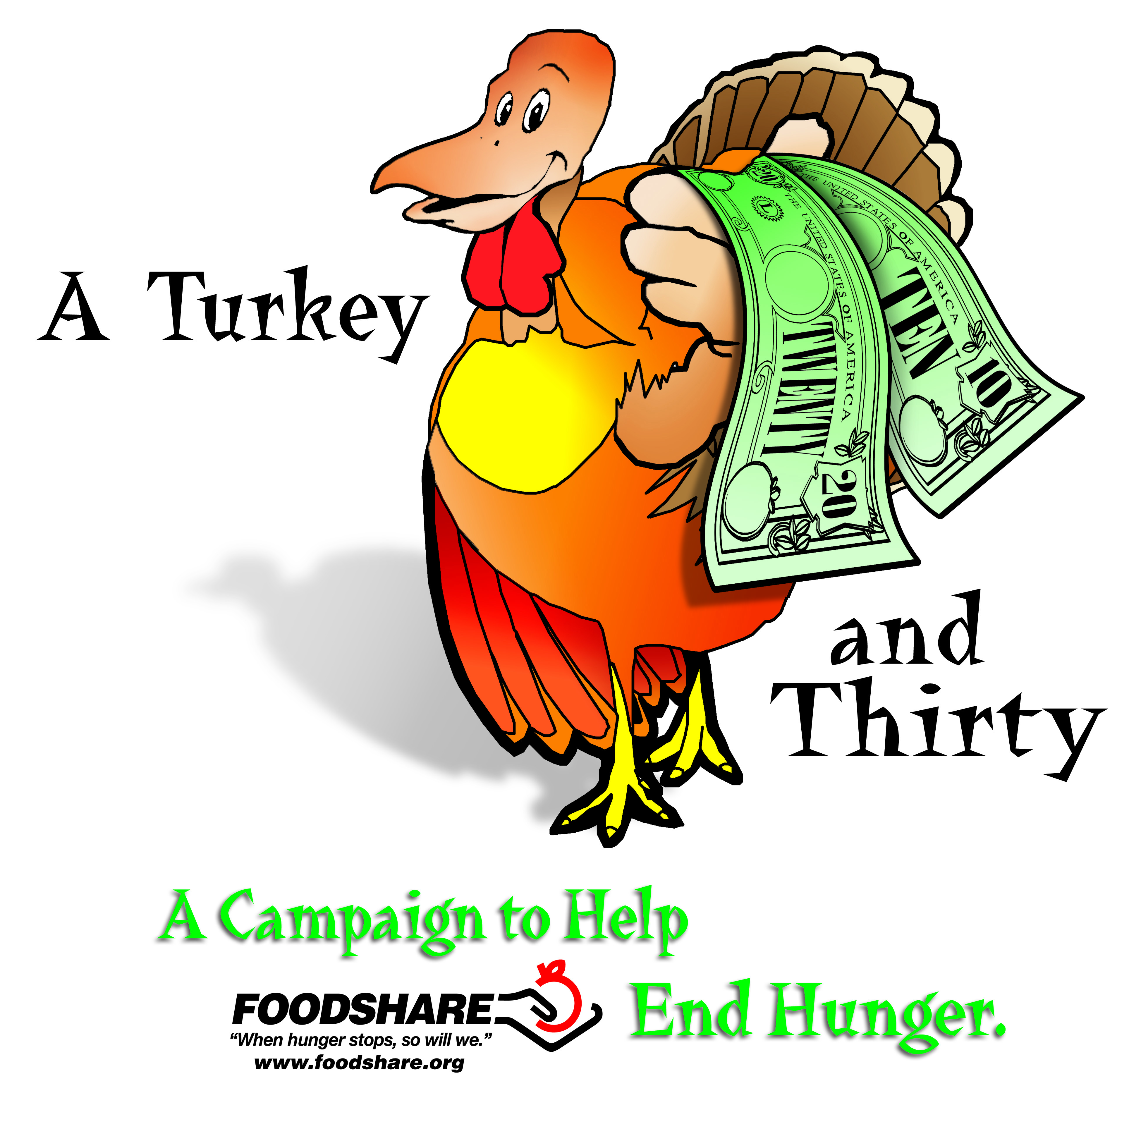

A Feast for Everyone

Dear [Name],
Thanksgiving is a holiday for everyone, which is why I am choosing to support Foodshare's Turkey and Thirty Campaign. Together we can ensure all of our friends and neighbors will join in the celebration. Last year’s campaign provided 15,871 local families with a traditional Thanksgiving meal!
For every $14 we raise this year, Foodshare is able to provide a turkey for one of our neighbors this holiday season. The more you give, the more families we can help!
I hope you will consider making a gift, and please know that your support will make a world of difference to our neighbors in need this holiday season.
Happy Holidays to you and yours,
[Your Name]

